**ITCS 6114: Algorithm & Data Structures**

**Summer 2018**

**Project Report 2:**

Single Source Shortest Path and Minimum Spanning Tree

Implementation

**Programming Language used**

Java

**Team Members:**

Shashikant Jaiswal (801053461)

Shaily Barjatya (801054460)

**Problem 1:**

Find the shortest path in undirected graphs for a given source node. You will print out each path and the corresponding path cost after execution.

1. **INPUT -**

**Graph1**

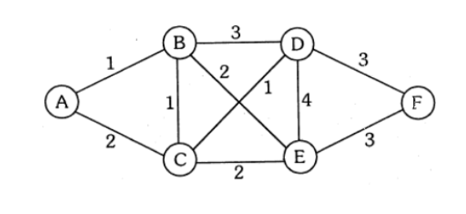

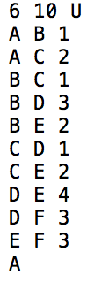

**OUTPUT RESULT –**

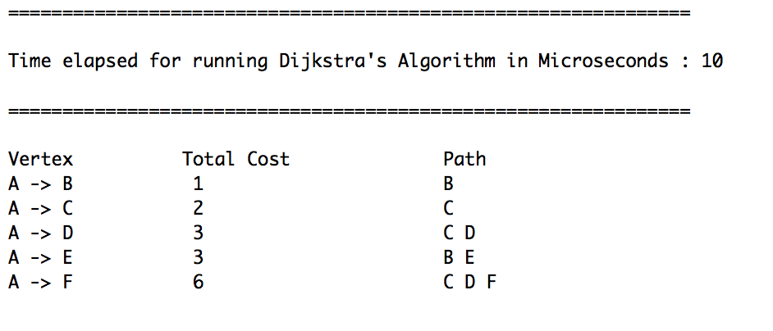

1. **INPUT -**

**Graph 2:**

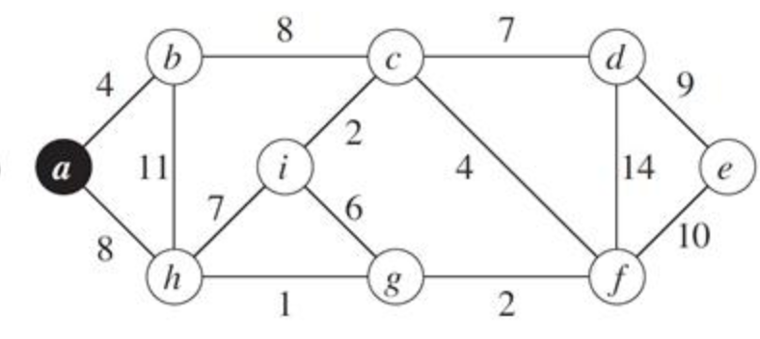

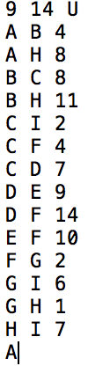

**OUTPUT RESULT –**

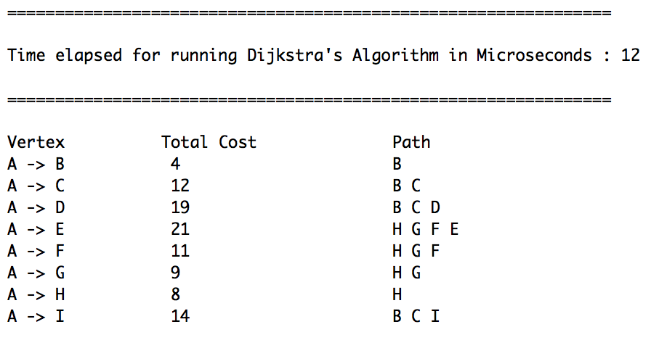

1. **INPUT -**

**Graph 3:**

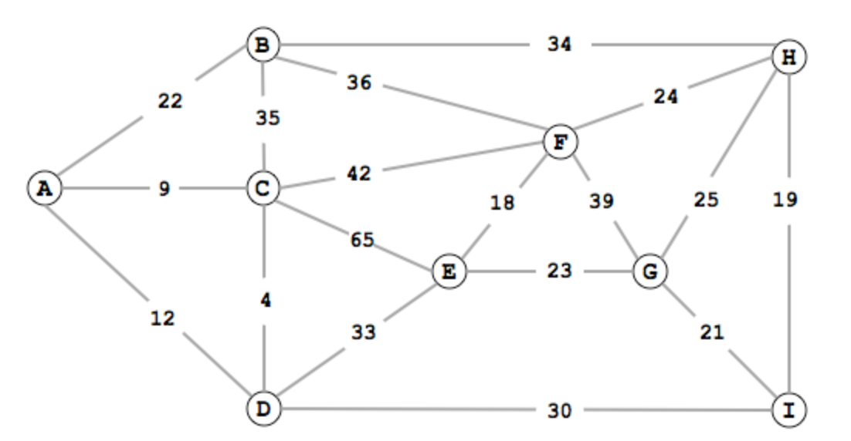

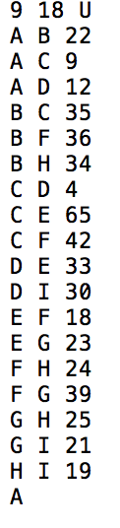

**OUTPUT RESULT –**

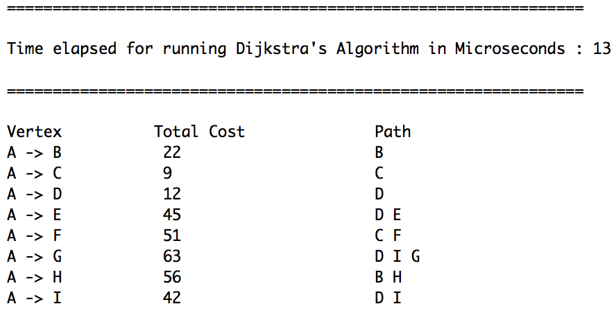

1. **INPUT -**

**Graph 4:**

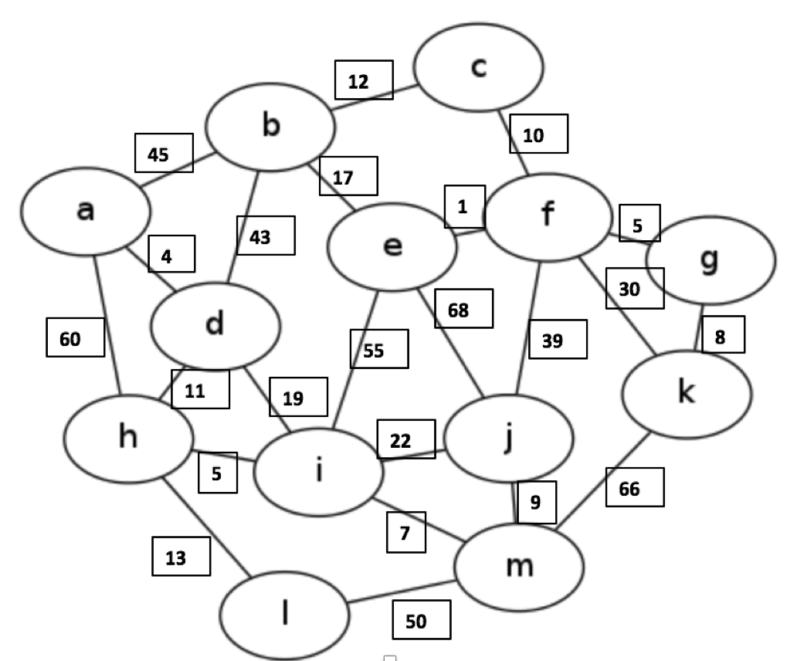

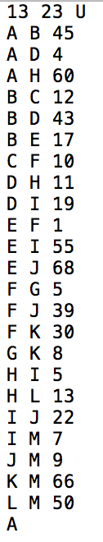

**OUTPUT RESULT –**

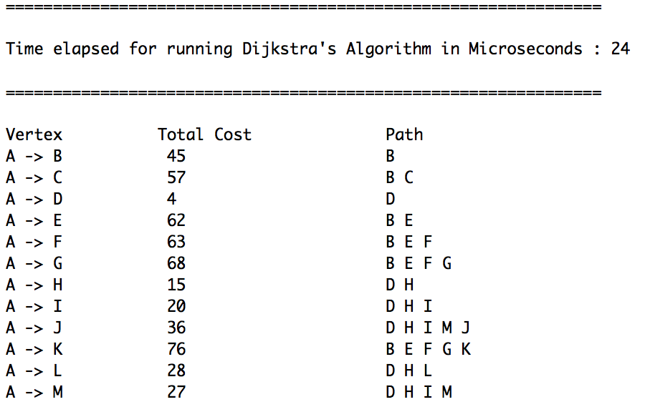

**CODE - Dijkstra**

**Problem 2:**

Given a connected, undirected, weighted graph, find a spanning tree using edges that minimizes the total weight. Use Kruskal or Prims algorithm to find the Minimum Spanning Tree (MST). You will printout the edges of the tree and total cost of your

answer.

1. **INPUT -**

**Graph 1**





**OUTPUT RESULT –**

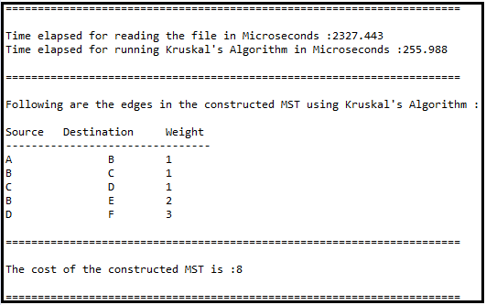

1. **INPUT -**

**Graph 2:**





**OUTPUT RESULT –**

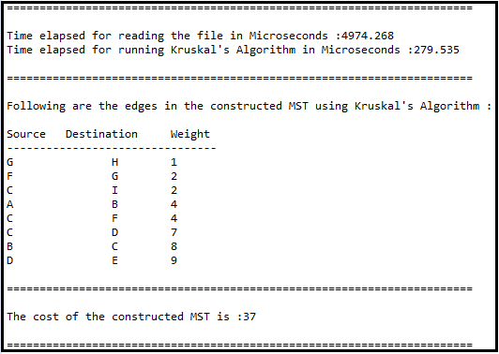

1. **INPUT -**

**Graph 3:**





**OUTPUT RESULT –**

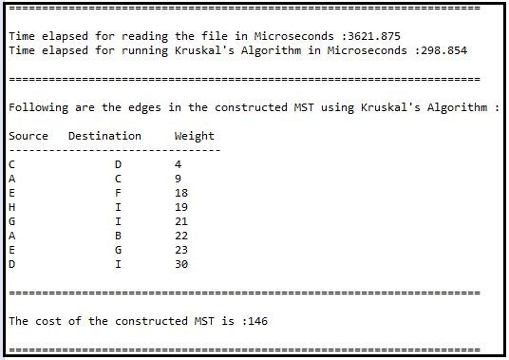

1. **INPUT -**

**Graph 4:**

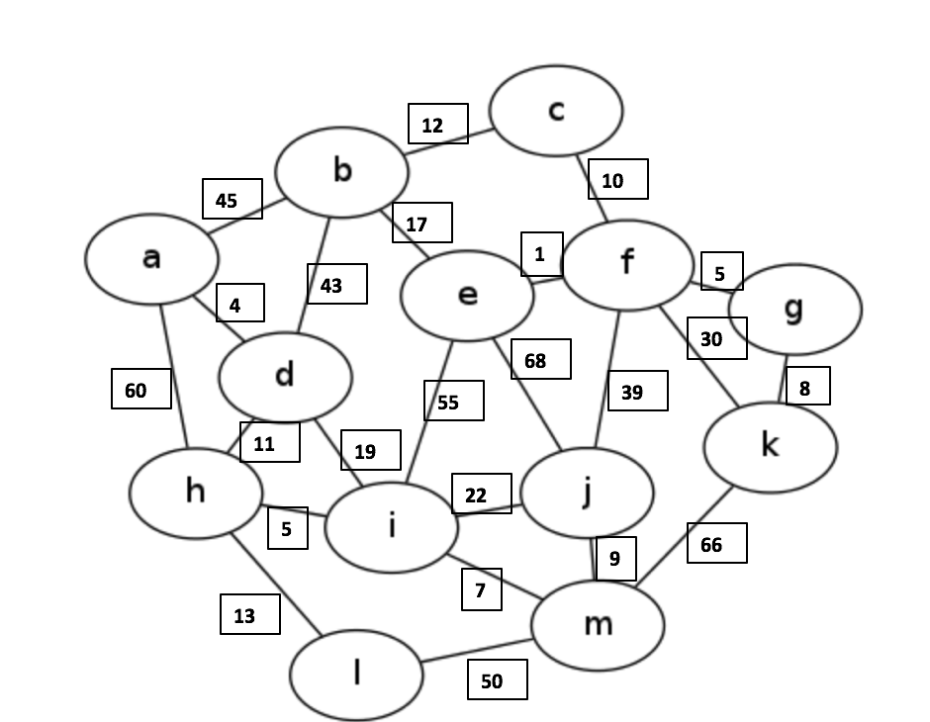



**OUTPUT RESULT –**

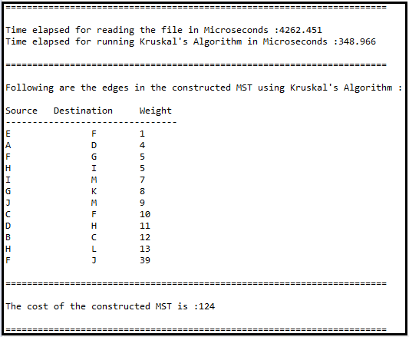

**CODE - Kruskal**



In the case of Prim's algorithm a minimum spanning tree for the graph is constructed. This tree connects that connects all nodes in the graph.It also has the least total cost among all trees that connect all the nodes. However, the length of a path between any two nodes in the MST might not be the shortest path between those two nodes in the original graph. Also, it will not matter that the path length between two nodes will not be optimal.

But , the Dijkstra's algorithm constructs a shortest path tree starting from some source node. A shortest path tree is a tree that connects all nodes in the graph and has the property that the length of any path from some start node to any other node in the graph is minimized. The shortest path tree is also not guaranteed to be a minimum spanning tree.

Also the Prim's algorithm works on undirected graphs.This is because the concept of an MST assumes that graphs are inherently undirected. On the other hand ,Dijkstra's algorithm will work fine on directed graphs, since shortest path trees can indeed be directed.